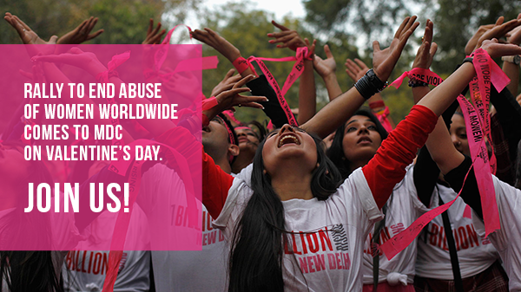

A day of love will become a day of action on Friday, Feb. 14, when thousands of students, community leaders, celebrities and survivors of violence will participate in One Billion Rising — a campaign to end human trafficking and the abuse of women worldwide.
The campaign began as a call to action based on the staggering United Nations statistic that one in three women on the planet will be beaten or raped during her lifetime. That adds up to more than one billion women and girls.
Join us at Wolfson Campus on Valentine’s Day for a street rally to end human trafficking and other forms of violence against women and girls. Afterward, we will gather at the campus’ Kyriakides Plaza for music, dancing and inspiring words from experts on and survivors of abuse.

